# Department of Computing

# 

**CS114: Fundamentals of Programming**

**Class: BESE 9AB**

# Lab 03: User Input and Arithmetics

**CLO1: Understand the syntax and semantics of different programming constructs**

**Date: 28th September 2018**

**Time: 9:00am -12:00pm /02:00pm-05:00pm**

**Instructor: Ms. Hania Aslam**

# Lab 03: User Input and Arithmetics

**Introduction**

This lab is designed to develop the understanding of students with python input and arithmetic operations.

**Objectives**

In this lab the students will learn and practice the user input and perform arithmetic on the obtained numbers.

**Tools/Software Requirement**

Python IDLE

**Output using print function**

#### The print function is used to display the message.

|  |
| --- |
| >>> print(1 + 1) 2  >>> print("The Latin 'Oryctolagus cuniculus' means 'domestic rabbit'.")  The Latin 'Oryctolagus cuniculus' means 'domestic rabbit'. |

#### Input

Another built-in function that you will find useful is input, which reads a single line of text from the keyboard. It returns whatever the user enters as a string, even if it looks like a number:

>>> species = input()

Homo sapiens

>>> species

'Homo sapiens'

In Python, every input result is char type. We can convert it into other types i.e int, float etc as:

>>> x= int(input())  
57

>>> x

57

There are no quotation marks which indicates that it is int type.

#### Arithmetic Operators

The Python interpreter can be used to express the arithmetic operators in a very simple way as describe below:

|  |
| --- |
| **# For Addition**  >>> 1 + 1  2 |
| **# For Multiplication**  >>> 2 * 3  6 |
| **# For Integer Division**  >>> 17//10 1 >>> -17//10 -2 |
| **#For Modulus**  >>> 27%10 7 >>> -27%10 3 |

#### Lab Tasks:

1. For each of the following expressions, what value will the expression give? Verify your answers by typing the expressions into Python.
   1. 9 - 3
   2. 8 * 2.5
   3. 9 / 2
   4. 9 / -2
   5. 9 // -2
   6. 9 % 2
   7. 9.0 % 2
   8. 9 % 2.0
   9. 9 % -2
   10. -9 % 2
   11. 9 / -2.0
   12. 4 + 3 * 5
   13. (4 + 3) * 5

**Answers:**

|  |  |  |
| --- | --- | --- |
| **Expression** | **Estimation** | **Python Result** |
| **a** | **6** |  |
| **b** | **20** |  |
| **c** | **4.5** |  |
| **d** | **-4.5** |  |
| **e** | **-4** |  |
| **f** | **1** |  |
| **g** | **1.0** |  |
| **h** | **1.0** |  |
| **i** | **-1** |  |
| **j** | **-1** |  |
| **K** | **-4.5** |  |
| **l** | **19** |  |
| **m** | **35** |  |

1. Which of the following expressions results in SyntaxErrors? Identify the syntax SyntaxErrors and type the reason of error along with the correct code by mentioning its sequence number.
   1. 6 * -----------8
   2. 8 = people
   3. ((((4 ** 3))))
   4. (-(-(-(-5))))
   5. 4 += 7 / 2

**Answers:**

|  |  |  |
| --- | --- | --- |
| **Expression** | **Type of Error** | **Correct Statement** |
| a | None | Same |
| b | Syntax error | people=8 |
| c | None | Same |
| d | None | Same |
| e | Syntax error | a+=7/2 |

1. Given variables x and y, which refer to values 3 and 12.5, respectively, use function print() to print the following messages. When numbers appear in the messages, variables x and y should be used.
   1. The rabbit is 3.
   2. The rabbit is 3 years old.
   3. 12.5 is average.
   4. 12.5 * 3
   5. 12.5 * 3 = 37.5

Insert code here

x=3

y=12.5

print('The rabbit is',x)

print('The rabbit is {} years old', format(x))

print(y,'is the average')

print('{} * {}'. format(y,x))

print('{} * {} is {}'. format(y,x,y*x))

Insert screen shot for output here

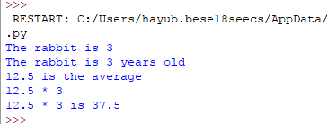

1. Write a program that prompts the user to input two values. Assign user defined values to two variables and then swap their values.

Insert code here

a=int(input("Enter a number:"))

b=int(input("Enter a second number:"))

print("Value in a is ",a)

print("Value in b is ",b)

c=a

a=b

b=c

print("After swapping the values!!!")

print("Value in a is ",a)

print("Value in b is ",b)

Insert screen shot for output here

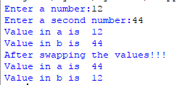

1. Using only the techniques you have learned so far, write a program that calculates the square and cube of the numbers from 0 to 10 and uses tabs to print the following table of values:

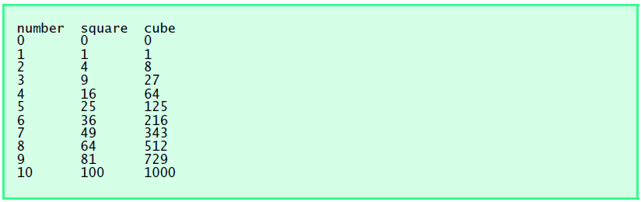

Insert screen shot for output here

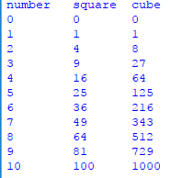

Insert code here

print("number\tsquare\tcube")

for a in range (10+1):

sq=0

sq=a*a

cube=0

cube=a**3

print(a,'\t',sq,'\t',cube)

1. Write a program that asks the user to enter two numbers, obtains the two numbers from the user and prints the sum, product, difference, quotient and remainder of the two numbers. Sample output is as following:

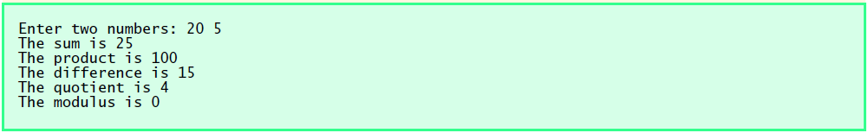

Insert screen shot for output here

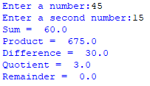

Insert code here

a=float(input("Enter a number:"))

b=float(input("Enter a second number:"))

print("Sum = ",a+b)

print("Product = ",a*b)

print("Difference = ",a-b)

print("Quotient = ",a/b)

print("Remainder = ",a%b)

1. Write a program that reads in the radius of a circle and prints the circle’s diameter, circumference and area. Use the constant value 3.14159 for π. Perform each of these calculations inside the print statement(s).

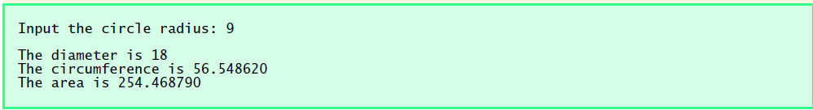

Insert code here

radius=float(input("Enter a radius of a circle:"))

print("Diameter = ",radius*2)

print("Circumference = ",2*3.14159*radius)

print("Area = ",3.14159*radius**2)

Insert screen shot for output here

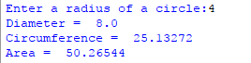

1. Using only the techniques you have learned so far write a python program which allows the user to print any multiplication table. An example interaction is shown below:

|  |
| --- |
| **This program prints any multiplication table.**  **Please enter the number of your choice: 2**  **2 * 1 = 2**  **2 * 2 = 4**  **2 * 3 = 6**  **2 * 4 = 8**  **2 * 5 = 10**  **2 * 6 = 12**  **2 * 7 = 14**  **2 * 8 = 16**  **2 * 9 = 18**  **2 * 10 = 20** |

Insert screen shot for output here

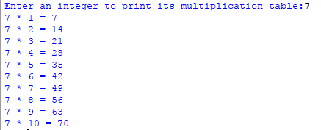

Insert code here

n=int(input("Enter an integer to print its multiplication table:"))

for a in range(1,10+1):

print('{} * {} = {}'.format(n,a,n*a))

**Deliverables**

Compile a single Word document by filling in the solution/answer part (as directed) along with the snapshots. Name your submission file as given below and submit this Word file on LMS before the deadline.

**Name – Registration No. – Section**

Name: Hamid Ayub

Regt. No: 12933118